untitled





**Submission of papers**

Authors are invited to submit their papers presenting the results of original research or innovative practical applications relevant to the workshop. The papers should be min. 4 and max. 6 pages. Pages over 6 will be charged additionally. The paper should be written in English according to the paper template, which can be downloaded from IWAMA website (<http://iwama.cslg.cn>)

The presentation at the workshop should not exceed 15 minutes. Full papers can be submitted to Kesheng Wang ([kesheng.wang@ntnu.no](mailto:kesheng.wang@ntnu.no)) or IWAMA website. We also make a poster session and industry session.

Each paper will be peer-reviewed by two experts and all accepted papers will be published in on-line proceedings by ***Atlantis press***, which will be sent to EI Compendex, and is available in full text online. Selected papers will be considered for publication in an expanded form in relevant international journals, such as Advances in Manufacturing, Journal of Intelligent Manufacturing, Application of Expert systems or others indexed by EI or SCI.

IWAMA 2017

*7th International Workshop of Advanced Manufacturing and Automation*

11 – 12 September 2017

Changshu Institute of Technology, Jiangsu, China

**First Announcement and Call for Papers**

**IWAMA** – **International Workshop of Advanced Manufacturing and Automation** – is an important international workshop for academic and industrial experts in the fields of advanced manufacturing and automation and will be organized as an annual event worldwide.,

Manufacturing and automation have assumed paramount importance and are vital factors for the maintenance and improvement of the economy of a nation and the quality of life. The field of manufacturing and automation is advancing at a rapid pace and new technologies are also emerging in the field. The challenges faced by today’s engineers are forcing them to keep on top of the emerging trends through continuous research and development.

**IWAMA** aims at providing a common platform for academics, researchers, practicing professionals and experts from industries to interact and discuss trends and advances in some areas of manufacturing and automation while sharing ideas and perspectives.

**Workshop Topics**

These are the main topics of IWAMA2017, but the topics are not limited to these. Authors should select 2-3 topics when they submit their papers.

1. Lean and Agile Manufacturing
2. Virtual and Grid Manufacturing
3. Resource and Asset Management
4. Logistics and Supply Chain Management
5. Fashion Logistics and Marketing
6. RFID Applications
7. Predictive Maintenance
8. Reliability and Maintainability in Manufacturing
9. Project Management
10. Renewable Energy Development
11. Knowledge management and Decision making
12. Intelligent Inspection
13. Robotics and Automation
14. Computational Intelligence
15. Design and Optimization
16. Product Life-cycle Management
17. Integration of CAD/CAPP/CAM/CIMS
18. Advanced Manufacturing Systems
19. Manufacturing Operations Management
20. Knowledge-based Manufacturing
21. Manufacturing Quality Control and Management
22. Sustainable Production
23. Diagnosis and Prognosis of Machines
24. Industry 4.0

* Intelligent Manufacturing Systems

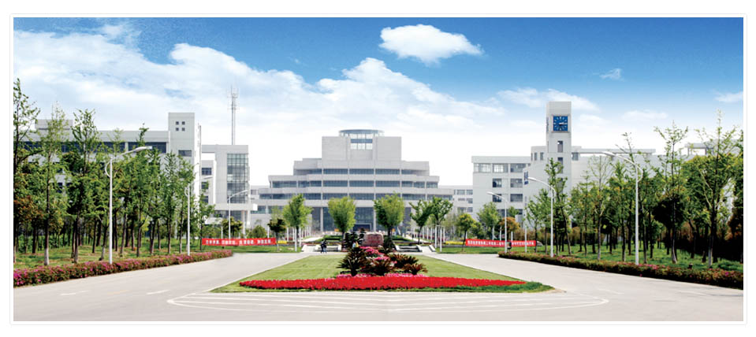

**Organizing Committee**

Lanzhong Guo (Chair), Ziqiang Zhou, Jian Wu

Wladimir Bodrow, Germany

Guy Doumeingts, France

Van Houten, Netherlands

Peter Bernus, Australia

Janis Grundspenkis, Latvia

George L. Kovacs, Hungary

Rinaldo Rinaldi, Italy

Gaetano Aiello, Italy

Romeo Bandinelli, Italy

Yafei He, China

Jawei Bai, China

Jinhui Yang, China

Dawei Tu, China

Minglun Fang, China

Binheng Lu, China

Xiaoqien Tang, China

Ming Chen, China

Xinguo Ming, China

Keith C. Chan, China

Xiaojing Wang, China

Jin Yuan, China

Yongyi He, China

Shili Tan, China

Ming Li, China

Chaodong Li, China

Cuilian Zhao, China

Chuanhong Zhou, China

Jianqing Cao, China

Yayu Huang, China

Shirong Ge, China

Jianjun Wu, China

Guijuan Lin, China

Shangming Luo, China

Dong Yang, China

Zumin Wang, China

Guohong Dai, China

Sarbjit Singh, India

Vishal S. Sharma, India

**Accommodation & travel information**

###### Attendees are suggested to stay in the hotel proposed later on.

Visitors arrive at Pudong Airport and may take a train to the hotel and the campus of Changshu Institute of Technology.

Daily temperature in September in Changshu is about 25 °C.

Jinghui Yang

[jhyang@sspu.edu.cn](mailto:jhyang@sspu.edu.cn)

Jan Ola Strandhagen, Norway

Kesheng Wang, Norway

Asbjørn Rolstadås, Norway

Per Schjølberg, Norway

Knut Sørby, Norway

Erlend Alfnes, Norway

Heidi Dreyer, Norway

Torgeir Welo, Norway

Leif Estensen, Norway

Hirpa L. Gelgele, Norway

Wei D. Solvang, Norway

Yi Wang, UK

Chris Parker, UK

Jorge M. Fajardo, Spain

Torsten Kjellberg, Sweden

Fumihiko Kimura, Japan

Gustav J. Olling, USA

Michael Wozny, USA

Byoung K. Choi, Korea

###### WORKSHOP SECRETARIAT

**Program Committee**

Haishu Ma

[haishu.ma@ntnu.no](mailto:haishu.ma@ntnu.no)

Ziqiang Zhou

[andy.z.zhou@gmail.com](mailto:andy.z.zhou@gmail.com)

Honorary Chairs:

Minglun Fang and Kesheng Wang

General Chairs:

Yi Wang, Jan Ola Strandhagen and Tao Yu

**Visa** – If requested, our workshop secretariat will provide an invitation letter to the participant to present together with the visa request to make the visa procedure simpler and faster.

**Venue** – The workshop will take place in Changshu Institute of Technology, Jiangsu, China.

Registration deadline

Preliminary program

Registration at site

01.08 2017

15.08 2017

11.09.2017

First announcement

Paper submission deadline

Acceptance notification

Final camera ready paper submission

10.11 2016

01.05 2017

01.06 2017

01.07 2017

**Important Dates**

**Regular and audience registration fees include:**

• Admission to all sessions

• Workshop kit

• Refreshment in coffee breaks

• Lunches and conference dinners

***\* Regular and poster papers are included in the Proceedings.***

**Registration and fees**

• Regular registration: €350

• Audience registration: €125

• Additional paper: €250

• Additional sheet: €50

• Poster paper: €150